**A STUDY ABOUT ONLINE SHOPPING**

A PROJECT REPORT

Submitted in partial fulfillment of the requirement for the award BSc degree programme

offered in the department of statistics

**SREE NARAYANA COLLEGE VADAKARA**

(Affiliated to the University of Calicut)



**DEPARTMENT OF STATISTICS**

SREE NARAYANA COLLEGE VATAKARA

2021

**A STUDY ABOUT ONLINE SHOPPING**

Project submitted in partial fulfillment of the requirement to the

award of degree BSc statistics

PRESENTED BY:

RIYA TK

VISMAYA KK

GUIDED BY

MISS.ANSI RAJAN

**CERTIFICATE**

This is to certify that the project entitled ”A STUDY ABOUT THE ONLINE SHOPPING” is a bonafide record of project work done during the year 2020 to 2021

MISS.ANSI RAJAN MISS.TEENA N DAS

INTERNAL GUIDE HOD OF THE STATISTICS

Submitted for project verification and viva voice examination held at SN college vadakara on and valued

Place: vadakara EXAMINER

Date:

* **ACKNOWLEDGMENT**

Firstly we would like to thank god, the compassionate and merciful for his grace duo to which this project has been made possible.

We use this opportunity to thank Dr. Sivadasan Thirumangalath the former principal of SN College who gave us permission to use the college facilities to complete the project.

More over we would like to express our sincere respect and gratitude to Ms. Teena head of the department of statistics SN College Vadakara for her inspiring guidance and constant encouragement during the course of work that enabled us to do this project successfully. Also we express our sincere thanks to Miss. Anci , Miss . Anuthra, Miss .Athira, lectures , department of statistics , SN College Vadakara for their valuable advice and encouragement during the course of this project work.

**CONTENTS**

CONTEXT………………………………………………………………………………………….

CHAPTER 1: INTRODUCTION……………………………………………………………5

PURPOSE OF THE STUDY………………………………………………………………….6

STUDY METHEDOLOGY…………………………………………………………………….6

CHAPTER 2: STATISTICAL TOOLS……………………………………………………….7

CHAPTER 3: ANALYSIS………………………………………………………………………..9

CONCLUSION……………………………………………………………………………………..17

BIBILOGRAPHY……………………………………………………………………………………18

QUESTIONNAIRE………………………………………………………………………………..19

* **CHAPTER 1:** **INTRODUCTION**

**CONTEXT**

Earlier, going to a shop required a lot of effort such as putting on your proper clothes, doing your hair and makeup making sure you have the cash, getting into your destination etc . All of these changed with online shopping .Now you don’t have to worry about any of these things because all your need is your computer and a cozy bed or a sofa and you can order your things right away, still staying at the comfort of your home.

Online shopping is a form of Ecommerce where consumer can directly buy goods and services from a seller over the internet without an intermediate. The purpose of online shopping is to save money, time, through online shopping one can save his valuable time. One can watch and select things he wants to buy. Through online shopping we can save money because prices are less than market prices and we receive our product at our home. When we are comparing traditional shopping with online shopping , traditional shopping is very time consuming. In case of online shopping, it allows people to shop anytime , anywhere and ofcourse with boundaries between countries.

In online shopping there is no need of transportation cost. The most important benefits is that save a lot of time. Most of us like to do shopping at weekends. But doing to the mall for shopping can consume entire day. Online shopping gives the freedom to choose from a multiple of seller under one roof. It gives the freedom to computer prices of different brands and sellers and took the best decision from online shopping we get item at much lower price and with lots of discounts. That is something which you won’t find at traditional shop. Now we don’t have to worry about carrying cash in our pockets. Because online in a much easier, safer and convenient way. Not only that you get a full refund or a replacement if your product has any kind of defect

* **PURPOSE OF THE STUDY**

The study focused on online shopping.

There are several objectives which are needed to be taken into consideration in carrying out this study. All this objectives are mentioned as follows:

* To find which app is more used for online shopping.
* To find whether the use of online shopping more in city/town/village.
* To find whether male/female use online shopping app more.
* To find why people choose online app for shopping.
* To check whether there is any relationship between gender and buying.
* To check whether there is any relationship between gender and hours spending.
* **STUDY METHEDOLOGY**

The survey was conducted in SN college Vadakara and different area at Vadakara during the period December 2020- March 2021 we took 150 samples for the study. The sampling method is followed by cluster sampling

* **CHAPTER 2 :STATISTICAL TOOLS**

BAR CHART

A bar chart is a chart with rectangular bars with lengths proportional to the values that they represent. The bar can be plotted vertically or horizontally. A vertical bar chart is sometimes called a column bar chart. A bar graph is a chart that uses either horizontal or vertical bars to show comparisons among categories. One axis of the chart shows the specific categories being compared , and the other axis represents a discrete value. Some bar graphs present bar clustered in group of more than one (grouped bar graphs), and others show the bars divided in to subparts to show cumulate effects(stacked bar chart).

**SPSS command**

Analyze->descriptive statistics->send variables to the dialogue box->charts->Bar diagram->Ok

PIE DIAGRAM

A pie diagram is often used to plot relative frequencies when the data are non-numeric. A circle is constructed and if sliced up intodistinct sectors, one for each different data value. The area of each sector, which represent relative frequencies of the values.

**SPSS command**

Analyze->descriptive statistics->send variables to the dialogue box->pie diagram->ok

CHI-SQUARE TEST **(** **Х² )**

The chi-square test is one of the simplest and most widely used non parametric test in statistical analysis. The chi-square distribution has many applications in situations that involve the test of the hypothesis concerning qualitative data. The quantity chi-square describes the magnitude of discrepancy between theory and observations. If chi-square is zero it means that the observed and expected frequencies completely co-inside. The greater discrepancy between the observed and expected frequencies shows the greater value of chi-square. The quantity chi-square is defined as

**Х²= $\sum_{i=1}^{n}{\frac{(Oi-Ei)²}{Ei}}$**

ONE SAMPLE KOLMOGOROV-SMIRNOV TEST

The one sample kolmogorov- smirnov test is used to test whether a sample comes from a specific distribution .We can use this procedure to determine whether a sample comes from a population that is normally distributed. One sample kolmogorov-smirnov test is non parametric test

Analyze→nonparametric test→legacy dialogs→one sample kolmogorov smirnov test

MANN- WHITNEY U TEST

The Mann-Whitney U test is used to compare whether there is a difference in the dependent variable for two independent group.It compare whether the distribution of the dependent variable is the same for the two groups and therefore from the same population

Analyze→nonparametric test→legacy dialogs→

QUESTIONNAIRE

A Questionnaire is a research instruments consisting of a series of questions and other prompts for the purpose of gathering informations from respondence. Although they are often designed for statistical analysis of the responses, this is not always the case. The questionnaire was invented by Francis Galton.

P –VALUE

The p- value is the probability of obtaining a value more extreme then a given test statistics, when the null hypothesis is true . The smaller the p- value more evidence against H0. Rationally ,researchers will reject a hypothesis. If the p- value is less than 0.05 . The general rule is that a small p-value is evidence against the null hypothesis while a large p-value means little or no evidence against the null hypothesis.

* **CHAPTER 3:ANALYSIS OF DATA**
* MAINLY USED ONLINE SHOPPING APP

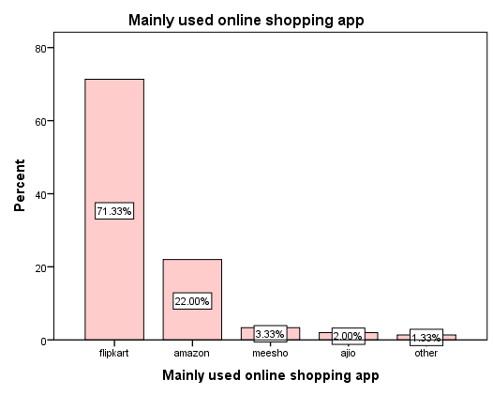

**INFERENCE:**

From the above Bar chart it is clear that most of the peopleuse flipkart

* LOCALITY OF LIVING

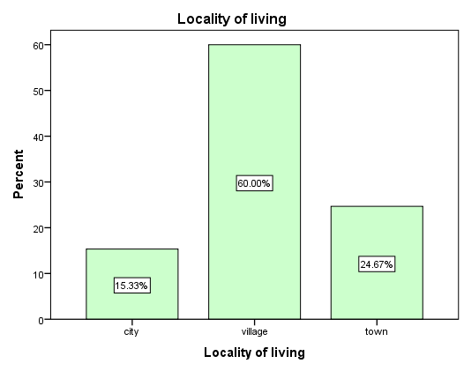

**INFERENCE:**

From the above bar diagram it is clear that people lives in villages are using the app more

* GENDER

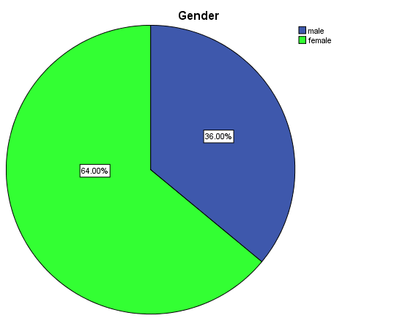

**INFERENCE:**

From the above pie chart it is clear that female use the app most.

* REASON FOR PURCHASING

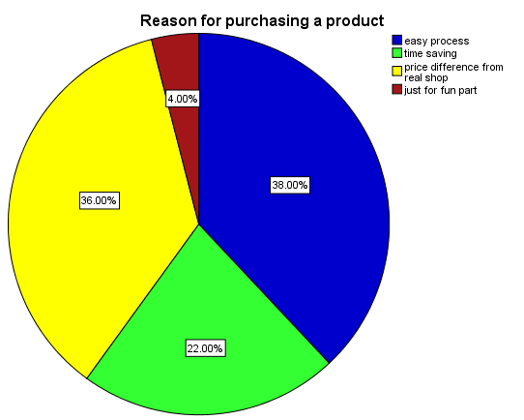

**INFERENCE:**

From the above pie diagram it is clear that people choose online shopping for easy process.

* CHI-SQURE TEST

GENDER/BUYING ITEM

Ho:THERE IS NO ASSOCIATION BETWEEN GENDER AND BUYING ITEMS

V/S

|  |  |  |  |
| --- | --- | --- | --- |
| **Chi-Square Tests** | | | |
|  | Value | df | Asymptotic Significance (2-sided) |
| Pearson Chi-Square | 53.463a | 4 | .000 |
| Likelihood Ratio | 55.300 | 4 | .000 |
| Linear-by-Linear Association | 5.103 | 1 | .024 |
| N of Valid Cases | 150 |  |  |
| a. 4 cells (40.0%) have expected count less than 5. The minimum expected count is .72. | | | |

H1:THERE IS A ASSOCIATION BETWEEN GENDER AND BUYING ITEMS

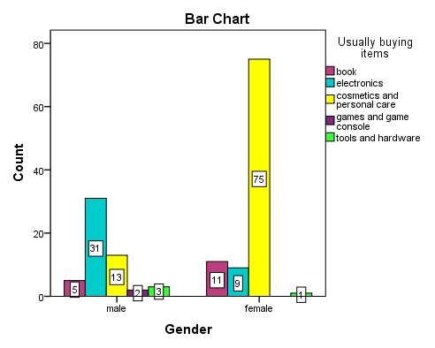

**INFERENCE:**

Since the p value =.000<0.05 so that we reject the null hypothesis.that is there is a association between gender and buying items

|  |  |  |
| --- | --- | --- |
| * TEST FOR NORMALITY   H0:The test distribution is normal  H1:The test distribution is not normal  **One-Sample Kolmogorov-Smirnov Test** | | |
|  | | Satisfied with online shopping |
| N | | 150 |
| Normal Parametersa,b | Mean | 2.0733 |
| Std. Deviation | 1.65110 |
| Most Extreme Differences | Absolute | .402 |
| Positive | .402 |
| Negative | -.258 |
| Test Statistic | | .402 |
| Asymp. Sig. (2-tailed) | | .000c |
| a. Test distribution is Normal. | | |
| b. Calculated from data. | | |
| c. Lilliefors Significance Correction. | | |

**INFERENCE**

Since 0.000<0.05 we reject the null hypothesis.Therefor the test distribution is not normally distributed .So we move mann-whitney U test

* MANN-WHITNEY U TEST

H0:µ1=µ2

H1:µ1≠µ2

|  |  |
| --- | --- |
| **Test Statisticsa** | |
|  | Hours spending for the app |
| Mann-Whitney U | 2579.000 |
| Wilcoxon W | 4064.000 |
| Z | -.052 |
| Asymp. Sig. (2-tailed) | .959 |
| a. Grouping Variable: Gender | |

INFERENCE:

Since 0.959>0.05 we accept null hypothesis.That is there is a relation between hours spending for the app and gender

|  |
| --- |
| * **CONCLUSION**   From our study we got the following conclusions they are :   * Flipkart is more used app for online shopping. * The use of online shopping app is more in villages. * Females use the online shopping app more than males. * For easy process people choose online shopping app. * There is a relationship between gender and buying items. that is males are focused on electronic items and females are focused on cosmetics and personal care. * There is no significant difference between hours spending and gender. |

* **BIBILOGRAPHY**

1.SPSS explained Perry R Hinton,Charlotte&Brownlow,Isabella McMurry&Bob

Cozens,Routledge

2. SC Gupta, V.K Kapoor(1970),Fundamentals of Mathematical Statistics ,Sultan

Chand & Sons

**STUDY ABOUT ONLINE SHOPPING**

Gender: Male[ ] Female[ ]

Occupation:Student[ ] Government Employ[ ] Buisness[ ]

IT profession[ ] Others[ ]

1. Age range

a) Below 15 [ ] b) 16-20[ ] c) 21-30[ ] d) 31 or more[ ]

2. Relationship status

a) Single[ ] b) Married[ ] c) Divorced[ ]

3. Family status

a) Single [ ] b) Joint family[ ] c) Nuclear[ ]

4. Are you living in

a) city [ ] b) Village[ ] c) Town[ ]

5. where do you mainly shop online?

a) Flipkart [ ] b) Amazon[ ] c) Meesho[ ] d) Ajio [ ] e) others[ ]

6. Do you use branded items or not?

a) Yes[ ] b) No[ ]

7. What do you usually look for on online shopping?

a) Books [ ] b) Electronic items [ ] c)Cosmetics and personal care[ ]

d) Games and game console [ ] e) Tools and hardware[ ]

8. Are you satisfied with the product images provided?

a) Satisfied [ ] b) Not satisfied[ ] c) Partially satisfied[ ]

9. How much do you spend for online shopping per month?

a) Below 500[ ] b) 500-1000[ ] c) Above 1000[ ]

10. What is the reason that makes you to purchase a product in online?

a) Easy process [ ] b) Time saving [ ]

c) Price difference from real shops [ ] d) Just for fun part [ ]

11. Which features do you look out for when you search on ecommerce website?

a) Speed of loading pages [ ] b) The design [ ] c) Layout [ ]

d) Others [ ]

12.Are you agree with the statement that “I am satisfied” with online shopping?

a) Agree [ ] b) Disagree[ ] c) Strongly disagree[ ] d) Strongly agree[ ] e) Neutral[ ]

13. Are you satisfy with the value of money on online purchasing?

a) Satisfied [ ] b) Not satisfied [ ] c) Partially satisfied [ ]

14. Which mode of payment do you prefer?

a) Cash on delivery [ ] b) Debit/credit [ ] c) UPI [ ] d) Net banking[ ]

15. Do you use return policy?

a) Yes [ ] b) No [ ]

16. Are all the items you are looking for is available?

a) Yes [ ] b) No [ ] c) Occasionally [ ]

17. Do you agree with the statement:”the item you ordered arrive on time”

a) Agree [ ] b ) Disagree[ ] c) Strongly agree[ ] d) Strongly disagree[ ] e) Neutral[ ]

18 .During a normal day how many hours do you spend for this app

………

19. Does the app provide any offers?

a) Yes [ ] b) No [ ]

20. Do you get any rewards from the app?

a) Yes [ ] b) No [ ]

21. Do you give rating for the item you purchased?

a) Yes [ ] b) No [ ]

22. Did you get any profit through this app?  
a) Yes [ ] b) No [ ]

23. Are you happy with this app?

a) Yes [ ] b) No [ ]

24. Are you sure the app is safe?

a) Yes [ ] b) No [ ]

25. Do you have any bad experience from this app?

a) Yes [ ] b) No [ ]

26. Is online shopping better than offline shop?

a) Yes [ ] b) No [ ]

27. What are the main fears that hold you from doing online shopping?

a) Cyber security [ ] b) Payment fraud [ ]

c) Quality of product [ ] d) Price is higher in online [ ]

e) Shipping cost involved [ ] f) No fear [ ]